**Step 1:- Creating a file with .txt extension as Demo.txt**

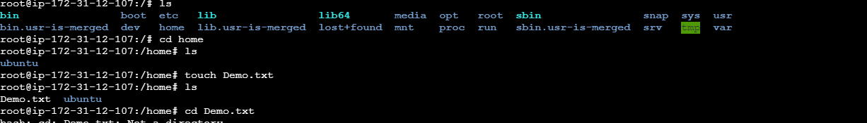

**Step 2:- Changing the permission of the file as follow**

Any user can read it, group can read/write & owner can read/write/execute it

**Numeric method**

Owner –Read/write/Execute -7(rwx)

Group –Read/Write -6(rw)

Other user – Read -4(r)

**Command for the above**

**Chmod 764 /home/Demo.txt**

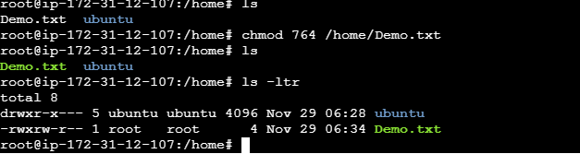

Or

**Symbolic method**

Owner –Read/write/Execute u= rwx

Group –Read/Write g= rw

Other user – Read o= r

**Command for the above**

**chmod u=rwx,g=rw,o=r /home/demo.txt**

